Name(s):
Date:
Class Period:

Proof of concept – Who needs paper?
All the answers to this packet need to be saved in this document (with a new name) and sent to me by email.
All my specific instructions are in red.
You can’t edit this document directly, but, have to save it with a new name to your own computer/tablet/device.
You will have to do some work on paper as well, but, all of the answers have to be in this document.
You can work alone or in pairs. Groups of 3 will be graded at a higher standard.
You actually have to READ the packet and instructions to do it correctly.

Bird Brains || student handoutP

On the surface, mushrooms and monkeys don’t seem to have much in common. But at the genetic level, these two organisms aren’t so different after all. Monkeys, mushrooms, and just about all other living creatures have a gene that codes for a protein called Cytochrome C, which plays a central role in releasing energy from food. Genes and proteins that govern
such basic survival functions tend to be shared by many organisms, making them an ideal tool for scientists who want to learn more about relationships among species. In this activity, you will use Cytochrome C data to predict evolutionary relationships between humans and six other species.

Procedure
1 Brainstorm some of the similarities and differences between humans and each of the organisms
below. What are some of the criteria scientists might use to determine how closely related,
in evolutionary time, two organisms are? Discuss with a partner and share your ideas with the class.
DO THIS WITH YOUR PARTNER AND TYPE YOUR ANSWER IN THE BOX BELOW:

2 Predict how recently humans shared a common ancestor with each organism listed below. Write your predictions in a paragraph and explain your reasoning, including the criteria you discussed in Step 1 above. Consider features that humans share with each organism, as well as ways in which humans differ from each one.
DO THIS WITH YOUR PARTNER AND TYPE YOUR ANSWER IN THE BOX BELOW:

3 Compare the Cytochrome C amino acid sequence in humans to each of the organisms listed below. You will find amino acid data on the Amino Acids
in the Protein Cytochrome C. For each organism, circle each amino acid that differs from the human sequence. (YOU CAN’T EASILY CIRCLE THIS ONLINE, BUT, YOU CAN TRY TO ADD SHAPES ON TOP OF THE PICTURE. I’VE DONE A FEW FOR YOU).

Note: “*” indicates an amino acid that is missing in some species. In places where one species has “*” and the other has a letter, count that as a difference.

4 Write down the number of differences between a human and a:
Differences between human and
Tuna
Gray whale
Snapping turtle
Rhesus monkey
Chicken/turkey
Neurospora

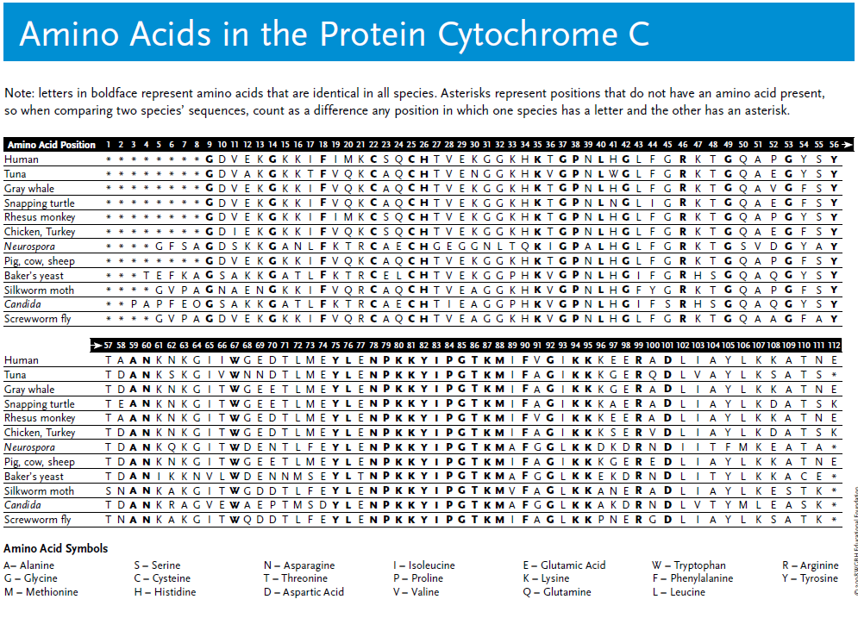

Answer the questions in the boxes
Questions

1 Based on the amino acid sequence data you collected, which organism are humans most closely related to? Which organisms are humans most distantly related to? Explain your reasoning.

2 What additional data or information might help you confirm the statement you made above?

3 Does your answer to Question 1 above match the prediction you made in Step 2 of the Procedure? Explain your answer.

4 Explain how amino acid sequence data can help scientists infer patterns of evolutionary relationships between species.

W h o ’ s my cl o s e s t r e l ati v e ?

According to evolutionary theory, species that recently shared a common ancestor have more similarities in their DNA than ones that last shared a common ancestor long ago. By comparing the order of amino acids that make up the protein Cytochrome C and noting the differences in the arrangement, scientists can
infer relationships among species. In general, the more amino acids two species share, the more closely related they are in evolutionary time.

© 2008 WGBH Educational Foundation.

THIS ASSIGNMENT IS MORE DIFFICULT, SINCE YOU HAVE TO DO PART OF IT IN A DRAWING PROGRAM (PAINT) OR USING THE SHAPES YOU CAN INSERT IN WORD.
YOU HAVE TO INSERT THE DRAWINGS (2 OF THEM) INTO THE DOCUMENT.

READ THIS…REALLY.

MAKING CLADOGRAMS: Background and Procedures
Phylogeny, Evolution, and Comparative Anatomy

A. Concept: Modern classification is based on evolution theory.

B. Background: One way to discover how groups of organisms are related to each other (phylogeny) is to compare the anatomical structures (body organs and parts) of many different organisms. Corresponding organs and other body parts that are alike in basic structure and origin are said to be
homologous structures (for example, the front legs of a horse, wings of a bird, flippers of a whale, and the arms of a person are all homologous to each other). When different organisms share a large
number of homologous structures, it is considered strong evidence that they are related to each other. When organisms are related to each other, it means they must have had a common ancestor at some time in the past. If there are specific modifications of those features shared by different groups of organisms, we say that those features are “shared derived characters”.

When we do studies in comparative anatomy, and find different numbers of shared derived characters exist between different groups, we can draw a diagram of branching lines which connect those groups, showing their different degrees of relationship. These diagrams look like trees and are called "phylogenetic trees" or "cladograms" (CLAY-doe-grams); see examples provided by your teacher. The organisms are at the tips of the stems. The shared derived features of the homologous structures are shown on the cladogram by solid square boxes along the branches, and common ancestors are shown by open circles. The more derived structures two organisms share, the closer is their evolutionary relationship -- that is, the more recently their common ancestor lived. On the cladogram, close relationships are shown by a recent fork from the supporting branch. The closer the fork in the branch between two organisms, the closer is their relationship.

C. Objectives: Given some groups of organisms and some of their distinguishing characteristics, you will construct a cladogram, and properly interpret and analyze that cladogram in terms of how it shows common ancestry and degrees of evolutionary relationship.

D. Procedure:
Step 1. Using your textbook and the explanations below, determine which of the characteristics each
animal has. In the Data Table provided (on your Cladogram Worksheet), place an "x" in the
box if the animal has the characteristic.

Explanations of Characteristics:

set #1: Dorsal nerve cord (running along the back or "dorsal" body surface)
Notochord (a flexible but supporting cartilage-like rod running along the back or
"dorsal" surface)

set #2: Paired appendages (legs, arms, wings, fins, flippers, antennae) Vertebral column ("backbone")

set #3: Paired legs

set #4: Amnion (a membrane that holds in the amniotic fluid surrounding the embryo; may or may not be inside an egg shell)

set #5: Mammary glands (milk-secreting glands that nourish the young)

set #6: Placenta (structure attached to inside of uterus of mother, and joined to the embryo by the umbilical cord; provides nourishment and oxygen to the embryo)

set #7: Canine teeth short (same length as other teeth)
Foramen magnum forward (spinal cord opening, located forward, under skull)

Step 2: Below the Data Table on your Worksheet, make a Venn diagram, placing your seven animals in groups to illustrate those characteristics which different animals have in common. See example below:

Human: Foramen magnum forward
Horse: Placenta

Tuna: Backbone

Step 3: Using the Venn diagram of the groupings just completed (as a guide), draw a cladogram on the back of your Worksheet to illustrate the ancestry of these animals. The diagram should reflect shared characteristics as time proceeds. An example is shown below. Notice how the different animals are all at the same time level (across the top) since they all live today.

Example of Cladogram

TUNA HORSE HUMAN

Foramen magnum forward
TIME

Placenta

Backbone
# OF SHARED CHARACTERISTICS

BY NOW YOU SHOULD BE CLEAR ON THE PROCEDURE….PUT YOUR ANSWERS IN THE BOXES.

E. Summary: Explain at least three types of information which can be obtained from a cladogram.

F. Application: Three previously unknown vertebrates have been discovered in a rain forest in South America.
One animal is very similar to an iguana lizard. The second animal resembles a large rat. The third is
similar to a goldfish. Place these animals on your cladogram and explain why you placed them where
you did. THIS BOX IS FOR THE EXPLANATION. THE ANIMALS NEED TO BE ADDED TO THE CLADOGRAM

Step 1: DATA TABLE

Animals

SETS | TRAITS | Kangaroo | Lamprey | Rhesus  Monkey | Bullfrog | Human | Snapping  Turtle | Tuna
SET 1 | Dorsal Nerve Cord  Notochord
SET 2 | Paired Appendages  Vertebral column
SET 3 | Paired legs
SET 4 | Amnion  (Amniotic sac)
SET 5 | Mammary Glands
SET 6 | Placenta
SET 7 | Canine teeth short  Foramen magnum fwd
 | TOTALS of Xs-------->

Step 2: Venn Diagram:

EITHER PASTE YOUR VENN DIAGRAM HERE, OR USING WORD BUILD IT USING SHAPES.

Step 3: Cladogram:

EITHER PASTE YOUR CLADOGRAM DIAGRAM HERE, OR USING WORD BUILD IT USING SHAPES.

Classification of Life
LIFE AT ITS BIGGEST LEVELS….
FILL IN THE TABLE, I’VE DONE A FEW FOR YOU
For each taxon (line in the table) indicate if it is

1-Prokaryotic or Eukaryotic

2-Do cells in this taxon have cell walls, or not (or some do, some don’t)

3-Are they unicellular or multicellular (or some are unicellular and some are multicellular)

4-Are they heterotrophs or autotrophs (or some are heterotrophs and some are autotrophs)

5-Anything else interesting you can add about the taxon
Classification of Life

Domains | 1  Prokaryotic or  Eukaryotic | 2  Cell Wall or  no Cell Wall | 3  Unicellular or  Multicellular | 4  Heterotrophs or  Autotrophs | 5  Special Information
Archea | Prokaryotic
Bacteria
Cyanobacteria
Bacilli, Cocci, and
Spirochetes
Eukarya
Kingdom-Protista
Euglena
Dinoflagelletes
Diatoms | Eukaryotic |  |  |  | Cell wall - glass
Algae
Golden Algae
Green Algae
Red Algae |  |  |  | Autotrophs
Brown Algae
Forams
Radiolaria
Slime Molds
Kingdom-Fungi
Kingdom-Plantae
Kingdom-Animalia | Eukaryotic

